Creating a model

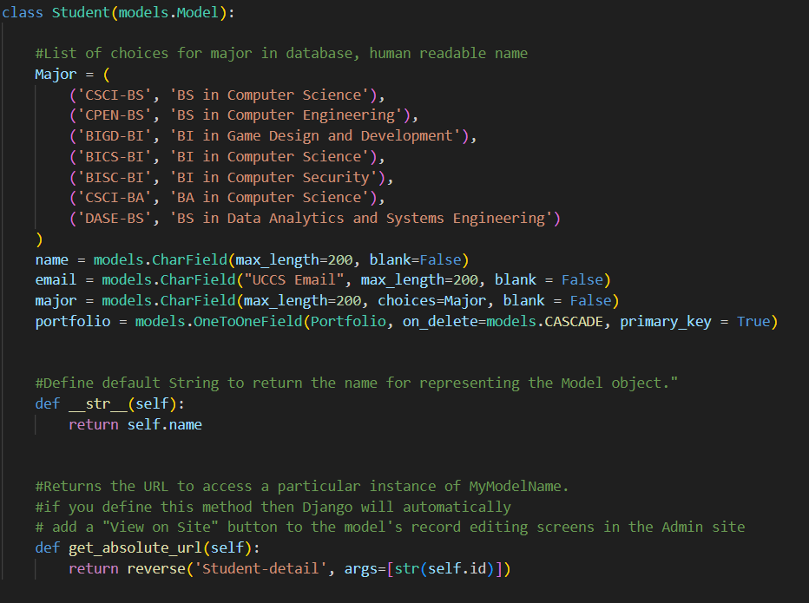

Models are classes where the class variables determine the features. In the example above, we first made a list for a choice field below. The fields are used to fill in data on database tables, and the required syntax can be found at [Django documentation | Django documentation | Django (djangoproject.com).](https://docs.djangoproject.com/en/5.0/)

We define class functions to return the name of the individual student in this case so that we have meaningful names when viewing in admin pages. The get_absolute_url function is a method to allow the model page to be viewable.

|  |  |  |  |
| --- | --- | --- | --- |
| Student | | | |
| name | email | major | Portfolio(key relationship) |